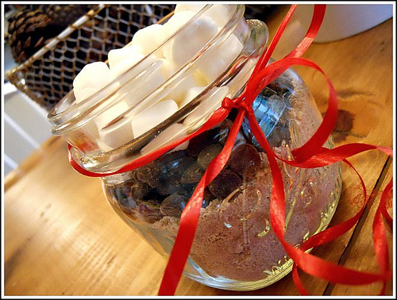
December Heart Healthy Tip
Need a winter warm-up? This homemade spiced hot chocolate with do just that and make you wonder why you ever bought the store bought variety! Also, can be a great gift idea to make a big batch of this homemade mix with instructions and put it into decorative jars for your friends and family this holiday season.

Nutritional information per serving
(1 cup/250 mL)
- Calories: 162
- Protein: 10 g
- Fat: 2 g
- Carbohydrate: 30 g
- Dietary fiber: 2 g

Ingredients (4 servings)
- 4 cups skim milk
- 4 tbsp unsweetened cocoa powder
- 4 tbsp sugar
- ¼ tsp cinnamon
Directions
Warm milk over medium-low heat. Whisk in cocoa powder, sugar and cinnamon. Heat until hot but do not boil.

